**Microsoft Excel Goal Seek**

**References**

Examples and additional details are available in recommended textbook:

*Microsoft Excel: Data Analysis and Business Modeling*, Wayne L. Winston

**6.3.2 Goal Seek**

The goal seek command searches for a solution by varying a parameter until a solution is found. Definitions:

Set cell: formula for the answer that you are seeking

To value: value that you want to achieve

By changing cell: the cell that changes until the Set cell matches the To value

In the example adapted from your book, let’s find the price that results in a break-even point. In other words, we will vary demand until profit equals zero. Use the spreadsheet tab GoalSeek. The following commands run GoalSeek.

1. Click on the Data tab at the top of the spreadsheet.
2. Click on What-if Analysis, Goal Seek.
3. For Set Cell, enter the cell that is the outcome variable that you want to match. Since we are measuring profit as the outcome, enter $B$7.
4. For the To Value, enter zero since we are trying to find the break-even point.
5. For the By Changing Cell, enter the cell which will change, in this case price B1.
6. Click OK to find the solution.

You should get the solution shown below.

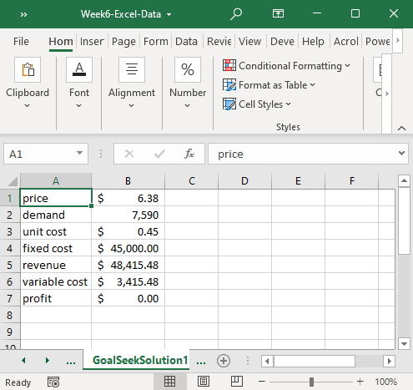

1. Now rerun GoalSeek with a starting price of 0.
2. Click on What-if Analysis, Goal Seek.
3. For Set Cell, enter the cell that is the outcome variable that you want to match. Since we are measuring profit as the outcome, enter $B$7.
4. For the To Value, enter zero since we are trying to find the break-even point.
5. For the By Changing Cell, enter the cell which will change, in this case price B1.
6. Click OK to find the solution.
7. What’s the difference? Why?

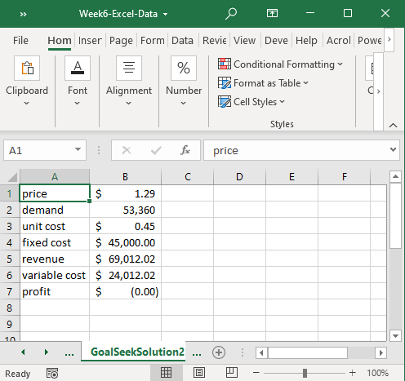

1. The profit curve is nonlinear with two break-even points

**Microsoft Excel Solver**

**6.4 Solver Add-In**

The Solver option is available as an add-in to Excel. The steps to add it are:

1. In Excel, click on the File tab, then Options
2. Click on Add-Ins
3. Click Analysis Tool Pack Add-in, then Go
4. Check the box for Solver Add-in, then OK

**Introduction to Solver**

Solver has the ability to search for an optimal solution subject to constraint. In contrast, goal seek would search for a solution that would match a specific value, such as demand-supply=0. Solver will find the maximum or minimum of a function, called the optimal feasible solution, if one exists. In some cases, particularly overly constrained problems, there will be no solution.

**Simple Optimization**

Recall the price-demand function from earlier.

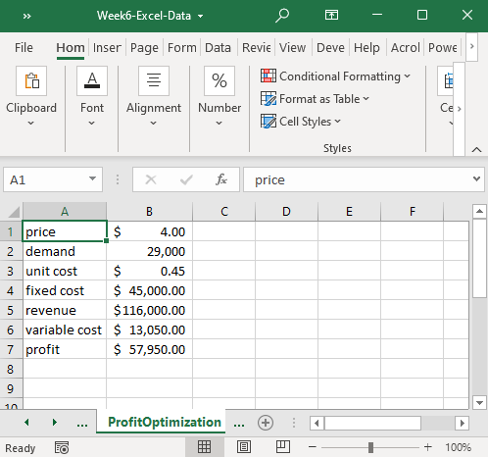

As price increases, demand decreases. Attempt to find the price that maximizes profit by changing the price.

Let’s use Solver to quickly calculate the optimal price.

1. Click on the Data tab, then click on Solver.
2. The Objective is the cell that you want to maximize or minimize. We want to maximize profit, so enter B7 in the objective, and click on Max.
3. Since we want to find the price that results in maximum profit, we will change price until we find a solution. In the box labelled “By Changing Variable Cells,” enter B1, which is where price is stored.
4. Now click Solve.

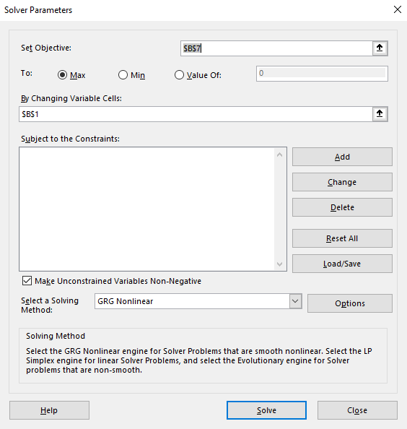

You can keep the solver solutions or restore original values.

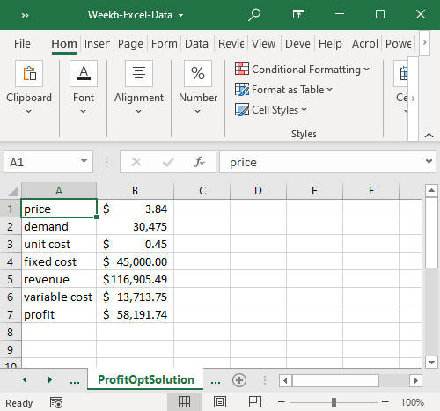

**6.6.2 Useful Functions for Solver**

One function that is helpful in setting up optimization problems is the SUMPRODUCT function. SUMPRODUCT first multiplies two columns or rows together (product), then adds the resulting values (sum). In the example below, labor used in cell D14=SUMPRODUCT($D$2:$I$2,D4:I4), which will multiply the values in D2:I2 against the paired value in D4:I4, i.e., D2*D4, E2*E4, etc., then add together the results. How are profit in cell D12 and raw material used in D15 calculated? This concept will be used in each of the following chapters.

In linear algebra (matrix algebra), this concept is called a dot product. Microsoft calls it SUMPRODUCT.

Use the ProdMix spreadsheet to see the example below.

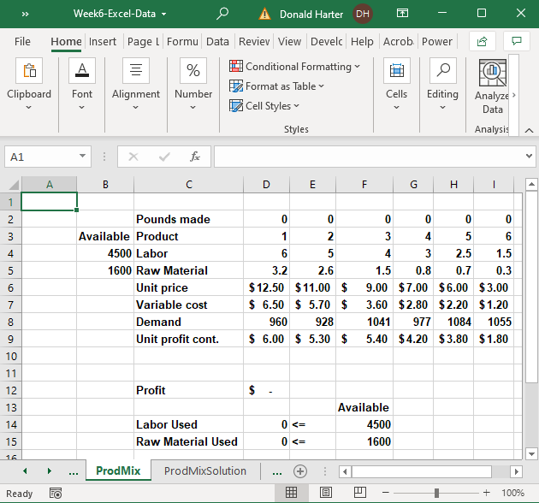

**6.7 Optimization Options**

The are four options for solving optimization problems in Solver. Each of the options depends on the nature of the objective function that you are trying to optimize. The four types of functions are linear, nonlinear with one optimum, nonlinear with multiple optima, and discontinuous or nondifferentiable functions. The following discussion shows the type of functions.

The simplest Objective functions will be linear. The Simplex method is sufficient when the function is linear.

Nonlinear equations require a nonlinear solution. GRG Nonlinear can solve nonlinear equations which have only one optimum. GRG stands for generalized reduced gradient.

Nonlinear functions with local optima require multiple starting points. GRG Nonlinear with multistart works here.

Equations with point having no slope or discontinuous functions must use evolutionary.

Picture of equation which is discontinuous

**Summary of Technique Selection**

The following table summarizes which techniques can solve each type of problem and the speed of the solution.

|  |  |  |  |  |
| --- | --- | --- | --- | --- |
|  | Solution Technique | | | |
| Problem | Simplex | GRG Nonlinear | GRG Nonlinear with multistart | Evolutionary |
| Linear | Yes | Yes | Yes | Yes |
| Nonlinear, one optimum | No | Yes | Yes | Yes |
| Nonlinear, multiple optima | No | No | Yes | Yes |
| Curve has point with no slope | No | No | No | Yes |
| Speed | Fastest | Fast | Slow | Slowest |

**6.8.2 Excel: Optimal Product Mix Optimization Demo**

For this problem, use the ProdMix spreadsheet.

In the optimal product mix problem, we are trying to produce six different products, where the labor and raw materials are constrained. The goal is to find the production volumes for each product that maximizes profitability.



The product numbers are listed in row 3, with the labor hours and raw material required to produce one pound of that product in rows 4 and 5. The maximum demand is in row 8. The maximum labor and raw materials available are also identified. Demand, labor, and raw materials are constraints.

To use solver, follow these steps:

1. Click on the Data tab.
2. In the Analysis group, click Solver.
3. Set Objective to the cell that you want to maximize or minimize. In this case, set it to profit ($D$12).
4. Since we want to maximize profit, make sure the Max button is checked.
5. By Changing Cell refers to what you want to vary. In this case, we want to vary product quantities to find the optimal production quantities. Click in the box and set this to D2:I2. The screen should look like the picture below.

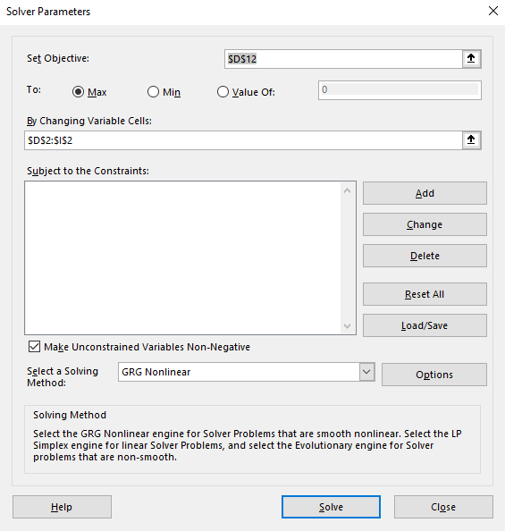

1. Next, add the constraints. First, click the Add button.
2. We want to impose a labor and resource constraint. We can do both simultaneously by entering D14:D15 and F14:F15 as below. Set the constraint direction to <=.
3. Click Add to add another constraint.

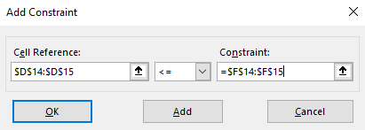

1. We also want to make sure that we don’t produce more than is demanded. After clicking add in the earlier step, Add Constraint lets you add more constraints. In this case, production (row 2) should not exceed demand (row 8). Set this demand constraint by entering D2:I2 and D8:I8. Set the constraint direction to <=.

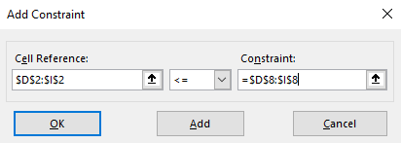

1. Since this is the last constraint, click OK. You should be returned to the following screen.

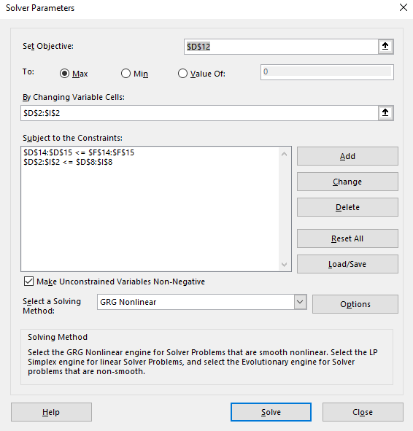

1. Finally, click on Solve. Select Keep Solver Solution if you want to save your answer. You can select three reports (Answer, Sensitivity, Limits) by clicking on them.

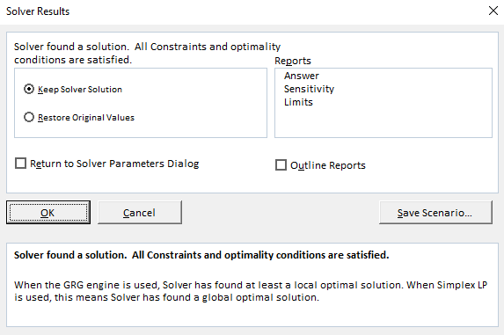

1. When you have made your selections, click OK. You should see the solution shown below. If you clicked on the additional reports, they will be listed as separate tabs.

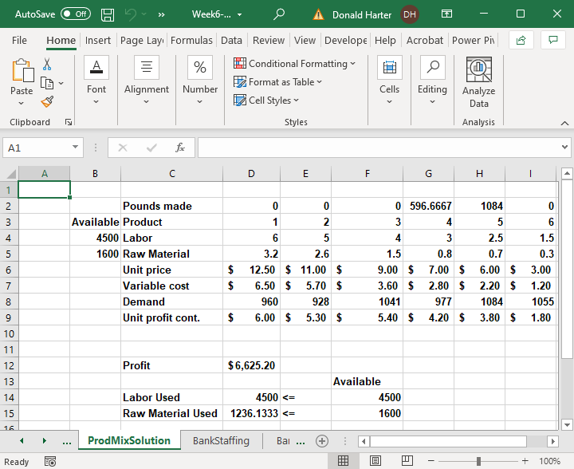

**6.9.2 Excel: Workforce Scheduling Optimization Demo**

In this example, we are trying to staff a bank with a minimum number of employees by day. The employees can work five consecutive days, starting on any one day. How many employees are needed to work in each shift? Use the **Bank Staffing** spreadsheet.

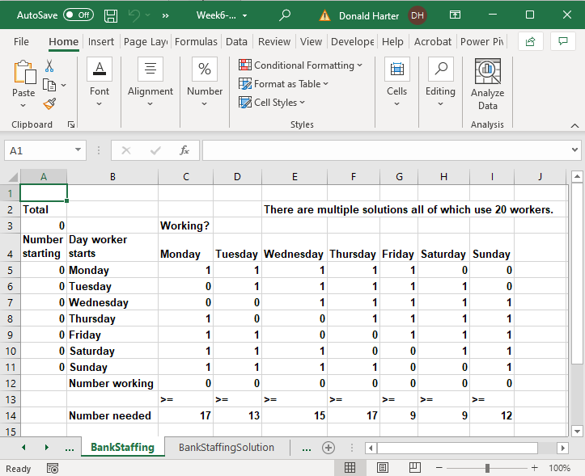

Cells A5:A11 have an initial assignment of people to shifts. Cell A5=1 means that one person will start working on a Monday. The cells C5:I5 show the days worked for a “Monday” shift. To calculate how many people are working each day, the Number working is the sumproduct. Management has determined the minimum number of employees that are required per day, listed as number needed. Now, let’s find a solution. The steps are:

1. Objective: minimize the number of employees.
2. Changing cells: number of employees who start work for each shift.
3. Constraints: number of employees working must be greater than or equal to the number of employees required.
4. Also, set a constraint that you should have whole people, i.e., people are integer.

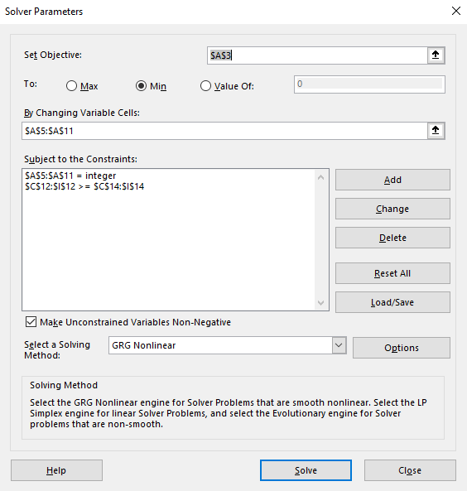

1. Run the solver as before.
2. Click OK to save the solution.

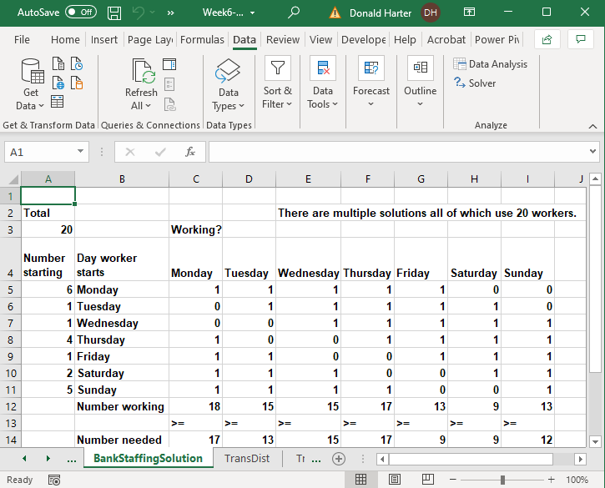

**6.10.2 Excel: Transportation and Distribution Optimization Demo**

The transportation and distribution problem describes an opportunity to minimize transportation costs. There are three distribution centers with inventory to be shipped to four destinations. The goal is to minimize transportation costs but satisfy all demand for the products at all locations. Use the **TransDist** spreadsheet. The initial spreadsheet looks like the picture below:

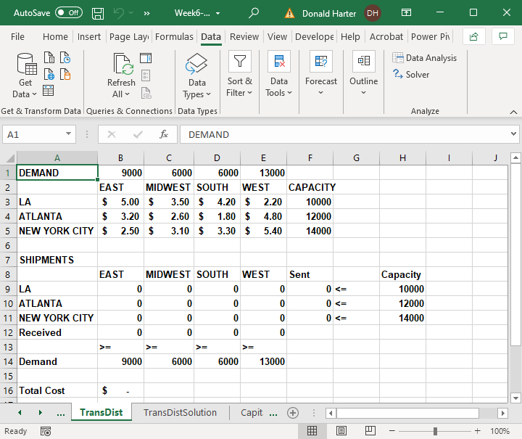

The steps to minimize cost are:

1. Set the Objective to the total cost B16. See the formula in the cell. Why does this work?
2. Set the changing cells (B9:E11) to amount in inventory at each city which is shipped to each region (destination).
3. Set the constraints to reflect the capacity of the distribution center (Sent <= Capacity).
4. Set the constraints to reflect that you must satisfy demand for each region (Received => Demand).

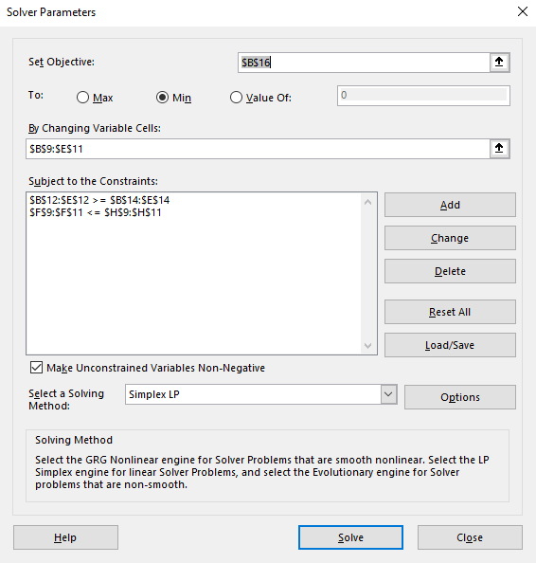

1. Click Solve, then OK.

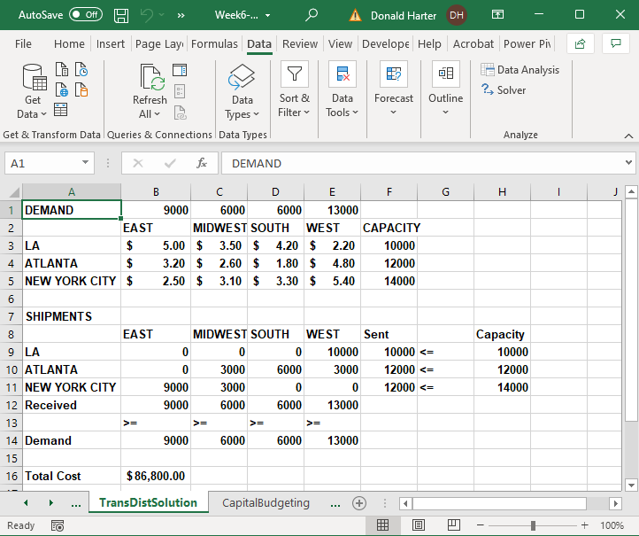

**6.11.2 Excel: Capital Budgeting Optimization Demo**

Using NPV (net present value) and IRR (internal rate of return), we can compare projects. Solver can be used for Capital Budgeting to select the optimal projects from a budgeting perspective.

In this case, we will use a trick called binary changing cells. A binary changing cell has a value of one or zero, reflecting that a project is selected or not. We will use a constraint of “bin” to designate a binary changing cell.

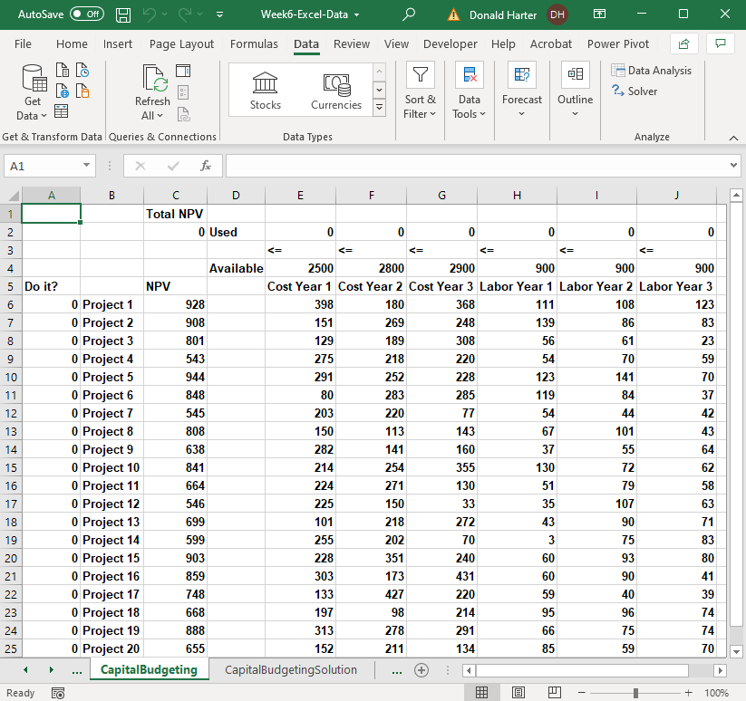

In the spreadsheet above, there are 20 projects, each with an NPV, yearly cost, and yearly labor requirement. However, there also is a limit to available funds and personnel, listed in the Available row. Your objective is to select the projects within the funding and personnel constraints which maximize total NPV.

The following steps maximize NPV:

1. Set target cell to Total NPV value.
2. Set changing cells to the range of A6:A25 zeroes and ones.
3. Set constraints to reflect that funds and employees (E2:J2) used cannot exceed what is available (E4:J4).
4. Now click Solve to see the result.

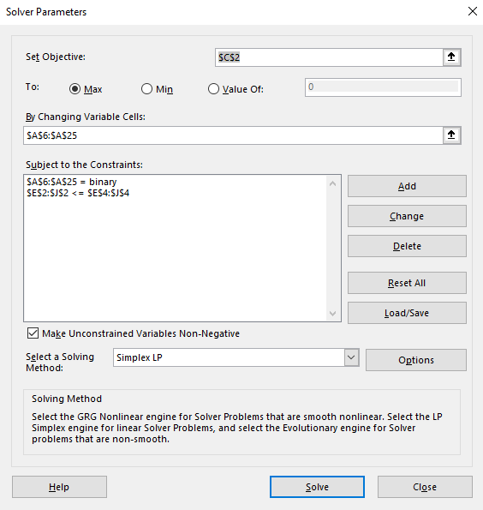

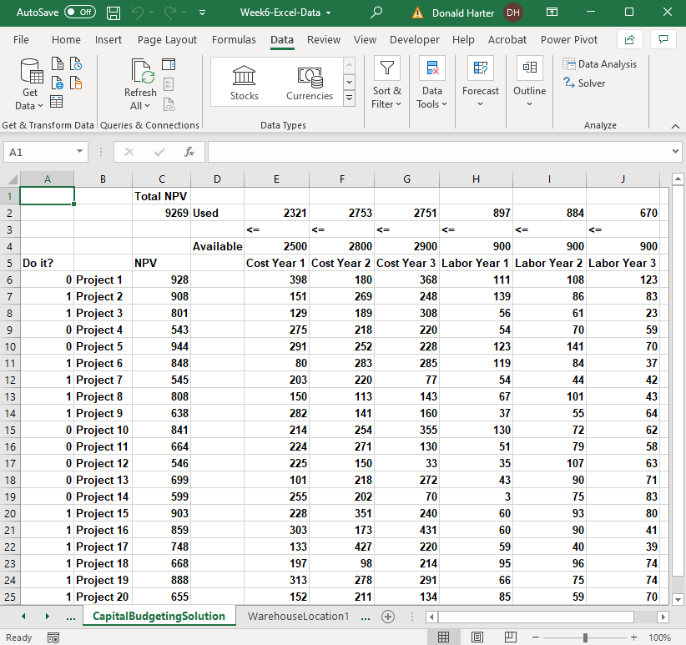

1. How would you handle other constraints, such as, if you select project 4, then project 3 must also be selected?
2. If you only have four project managers, how would you limit the selection to four projects?

**6.12.2 Excel: One Warehouse Location Optimization Demo**

You can use solver to find the optimal location for a warehouse, which minimizes the shipping distances for all shipments. We will try to find the optimal location for one warehouse to minimize shipment miles across the country, then expand to two warehouses.

1. For the first example in locating one warehouse, use the **WarehouseLocation1** spreadsheet.

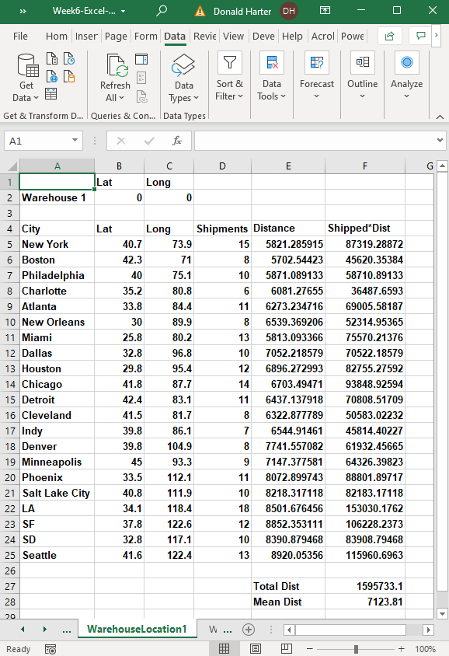

1. Each city is identified with latitude and longitude, the number of shipments going to that city, calculated distance from the city to the warehouse, and shipping miles (Shipped*Dist) for each city.
2. The goal is to minimize the Total Distance by finding the best location for warehouse 1.
3. To calculate the distance from each city to the warehouse, we will use the Pythagorean theorem:

C2 = A2 + B2

1. Or, taking the square root of both sides:

C = SQRT(A2 + B2)

1. For example, to calculate the distance from Dallas to Columbus:

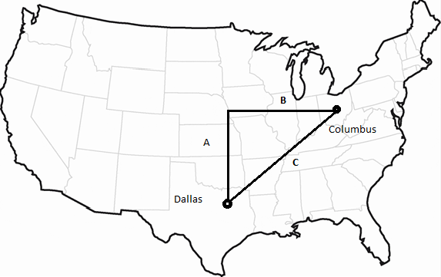

1. We can approximate the distance A:

A = latitude of Columbus – latitude of Dallas

1. We can approximate the distance B:

B = longitude of Columbus – longitude of Dallas

1. Then the distance C is:

C = SQRT((lat(Columbus)-lat(Dallas))2 + (long(Columbus)-long(Dallas))2)

1. One degree of latitude or longitude is approximately 69 miles, so the distance in miles is:

Distance = 69*SQRT((lat(Columbus)-lat(Dallas))2 + (long(Columbus)-long(Dallas))2)

1. In column E, we calculate the distance from the warehouse to each city.
2. In column F, calculate the number of shipments * distance, so we have total miles driven.
3. In F27, create total distance for all cities.
4. To run solver, click on the Data tab, then Solver.
5. The objective is to minimize total distance, so enter F27 in Set Objective.
6. We want to change the warehouse location, so set By Change Variable Cells to B2:C2, the latitude and longitude for the warehouse.
7. Select a solving method of GRG nonlinear.
8. Click Solve.

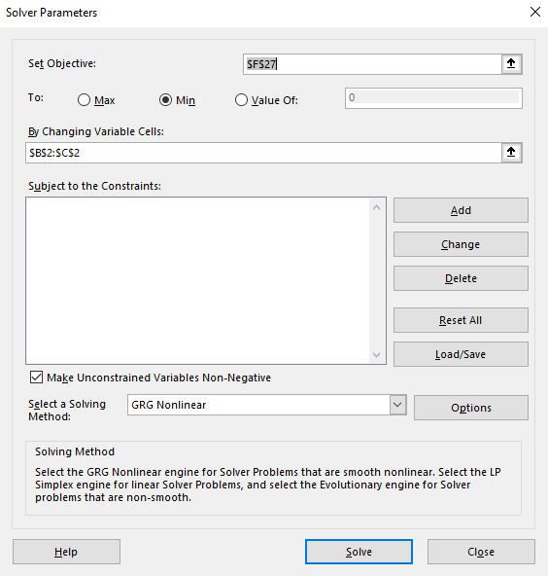

1. The solution is 36.81 N, 92.48 W. Use Google Maps to identify the location.

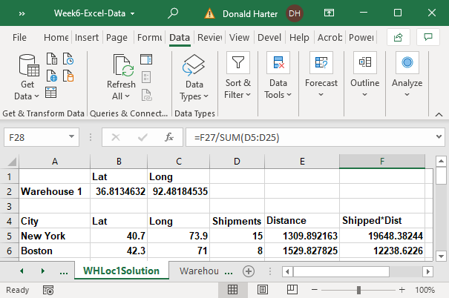

**6.12.3 Excel: Two Warehouse Locations Optimization Demo**

Now, assume that we will locate two warehouses.

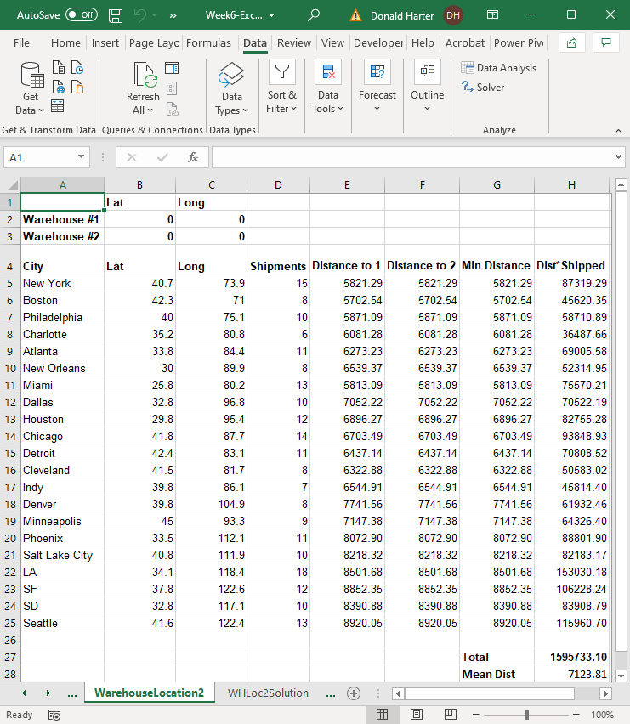

1. The latitude and longitude for our two warehouses are at the top of the screen.
2. The only additions that we have are two distance calculations (city to warehouse 1 and city to warehouse 2) and the minimum distance of the two. Our goal is to minimize total distance. In this case, we will assume that each city will receive shipments from the warehouse that is closest.
3. To run solver, click on the Data tab, then Solver.
4. The objective is to minimize total distance, so enter F27 in Set Objective.
5. We want to change the warehouse location, so set By Change Variable Cells to B2:C3, the latitude and longitude for the warehouses.
6. Select a solving method of GRG nonlinear.
7. Click Solve.
8. Does the result make sense? The two warehouses are located in the same latitude and longitude.
9. Solver is stuck in a local solution.

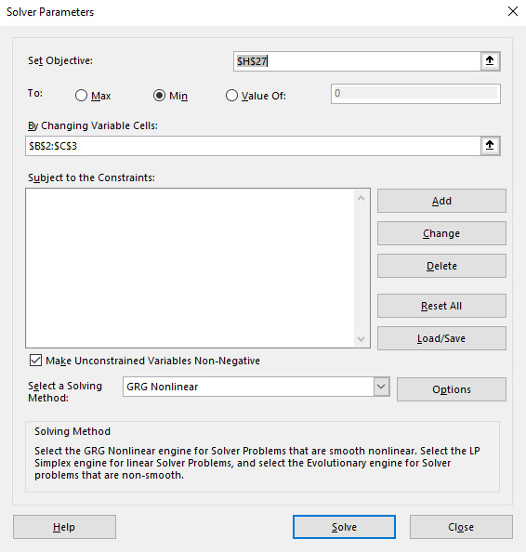

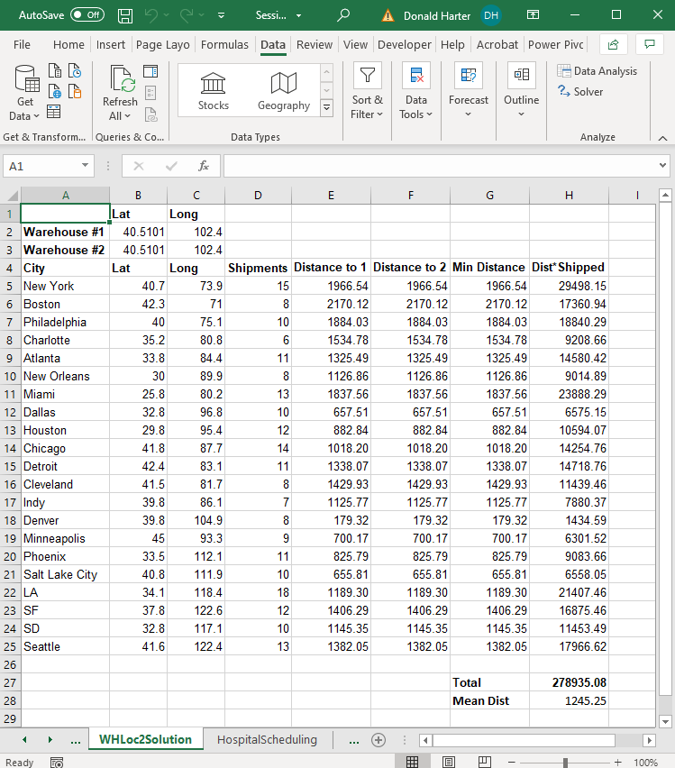

1. Now, let’s use GRG Nonlinear with multiple start points.
2. Click on solver.
3. Next to GRG Nonlinear, click on Options.
4. Click on the tab GRG Nonlinear.
5. Check the box Use Multistart, then click OK.
6. Note that it requires bounds on variables.

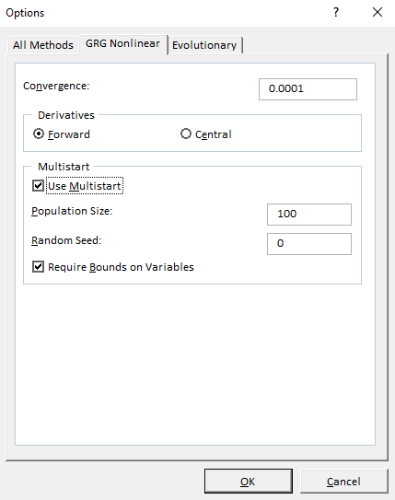

1. Next add constraints that put bounds on the variables.
2. In the Solver Parameters screen, under constraints, click Add.
3. Add a constraint for B2:B3 >= 0.
4. Add a constraint for B2:B3 <= 90.
5. Add a constraint for C2:C3 >= 0.
6. Add a constraint for C2:C3 <= 150.
7. Click Solve.
8. Use Google Maps to find the locations of the two warehouses.

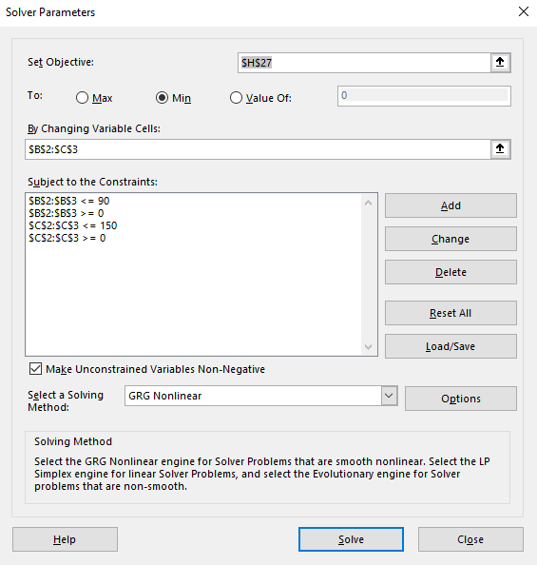

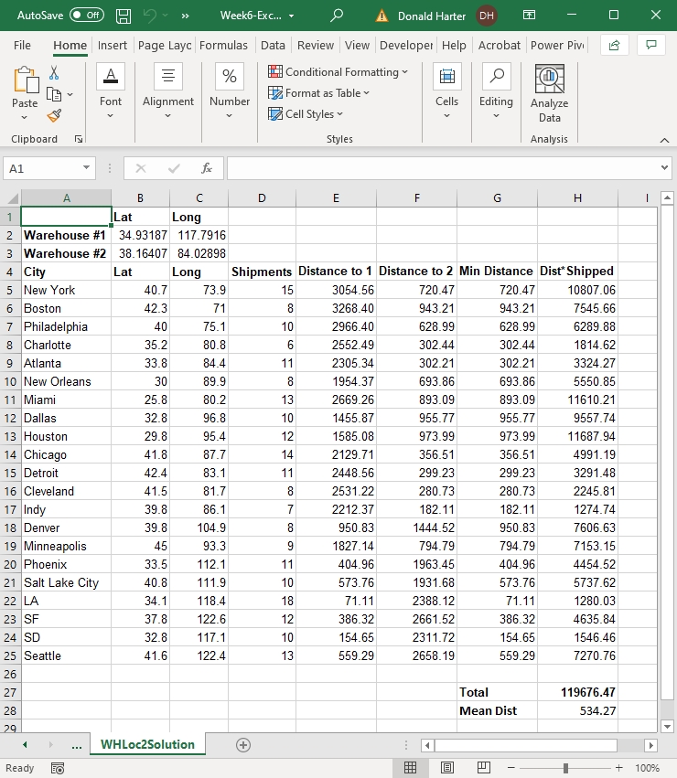

**6.12.4 Excel: Two Warehouse Locations Optimization Demo with Evolutionary Solver**

Run the same problem with Evolutionary

1. Set the objective to Total Distance (H27).
2. Set to Min so we minimize Total Distance.
3. Set By Changing Variable Cells to B2:C3.
4. Add a constraint for B2:B3 >= 0.
5. Add a constraint for B2:B3 <= 90.
6. Add a constraint for C2:C3 >= 0.
7. Add a constraint for C2:C3 <= 150.

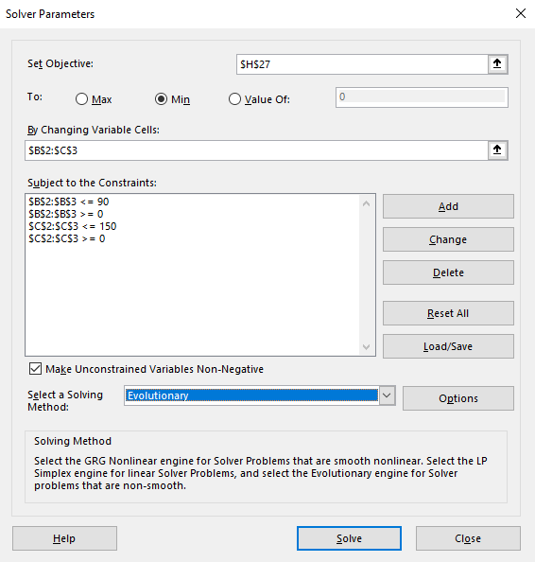

1. Change Select a Solving Method to Evolutionary.
2. Click on Options next to Evolutionary.
3. Change Mutation Rate to 0.5.
4. Check the box Require Bounds on Variables.
5. Click OK.

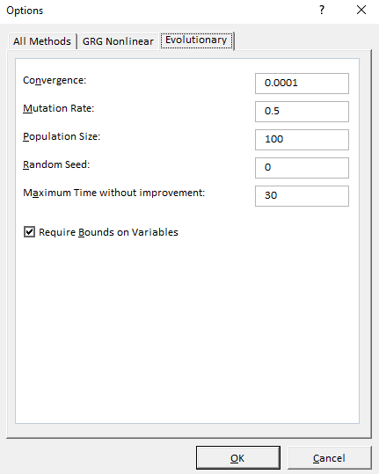

1. Solver will return the Evolutionary solution, which is the same as the nonlinear GRG with multistart solution.

